LAB EXPERIMENTS
Reg. No :192472244
Course Code: CSA0611
Course Name: DESIGN AND ANALYSIS OfALGORITHMS Tools used: Python Programming

- Write a program to Print Fibonacci Series using recursion.
Program :
n=int(input("Enter The Number Of Terms"))
a=0
b=1
for i in range(n):
print(a,end=" ")

a,b=b,a+b

output : 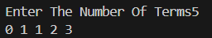

2. Write a program to check the given no is Armstrong or not using recursive function.
Program :
# Find The Armstrong
n = int(input("Enter a number: "))
original = n
sum = 0

while n > 0:
p = n % 10
sum += p ** 3
n //= 10

if sum == original:
print("It is an Armstrong number")
else:
print("Not an Armstrong number")

Output :
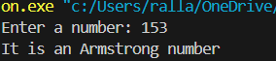

3. Write a program to find the GCD of two numbers using recursive factorisation
Program :

a=int(input("Enter Number :"))
b=int(input("Enter Number :"))
gcd=1

for i in range(1,min(a,b)+1):
if a%i ==0 and b%i ==0:
gcd=i

print("GCD",gcd)

# 2nd Method
a=int(input("Enter The Number:"))
b=int(input("Enter The Number:"))

while b!=0:
a,b=b,a%b
gcd=a
print("GCD",gcd)

Output :
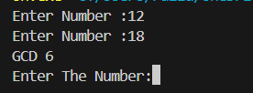
4. Write a program to get the largest element of an array.
Program :
arr1=list(map(int,input("enter the Elements in the List").split()))
largest=arr1[0]
for i in arr1:
if i > largest:
largest=i

print("Largest",largest)

Output:

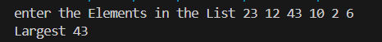

5. Write a program to find the Factorial of a number using recursion.
Program :
n=int(input("Enter A Number For Faactoriaal:"))
fact=1
for i in range(n,0,-1):
fact=fact*i
print(f"Factorail of {n}! {fact}")

Output: 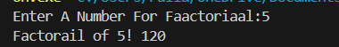
6. Write a program to check a number is a prime number or not using recursion.
Program :
#Write A prograam to find the Prime

n=int(input("enter a Number"))
flag=False

if n==1:
print(f"Its not A Prime Number ")

elif n>1:
for i in range(2,n):
if n%i ==0:
flag=True

break

if flag:
print("its Not a prime")
else:
print("its A Prime")
Output:
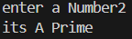

7. Write a program to perform Selection sort.
Program :
arr=list(map(int,input("Enter The Elements in Array :").split()))
n=len(arr)

for i in range(n):
min_index=i

for j in range (i+1,n):
if arr[j]<arr[min_index]:
min_index=j

arr[i],arr[min_index]=arr[min_index],arr[i]

print("Sorted ",arr)

Output:

8. Write a program to perform Bubble sort
Program :
arr=list(map(int,input("Enter Number of elements").split()))
n=len(arr)

for i in range(n-1):
for j in range(n-1-i):
if arr[j]>arr[j+1]:

arr[j],arr[j+1]=arr[j+1],arr[j]

print("Sorted",arr)

Output:

9. Write a program for calculating time complexity for multiply two Matrix

Program :
r1 = int(input("Enter rows for Matrix 1: "))
c1 = int(input("Enter cols for Matrix 1: "))

A = []
print("Enter elements of Matrix 1:")
for i in range(r1):
row = []
for j in range(c1):
row.append(int(input()))
A.append(row)

r2 = int(input("Enter rows for Matrix 2: "))
c2 = int(input("Enter cols for Matrix 2: "))

B = []
print("Enter elements of Matrix 2:")
for i in range(r2):
row = []
for j in range(c2):
row.append(int(input()))
B.append(row)

if c1 != r2:
print("Matrix multiplication not possible!")
else:
C = [[0 for j in range(c2)] for i in range(r1)]

# Multiply
for i in range(r1):
for j in range(c2):
for k in range(c1):
C[i][j] = C[i][j] + A[i][k] * B[k][j]
print("Resultant Matrix:")
for i in range(r1):
for j in range(c2):
print(C[i][j], end=" ")
print()

Output:
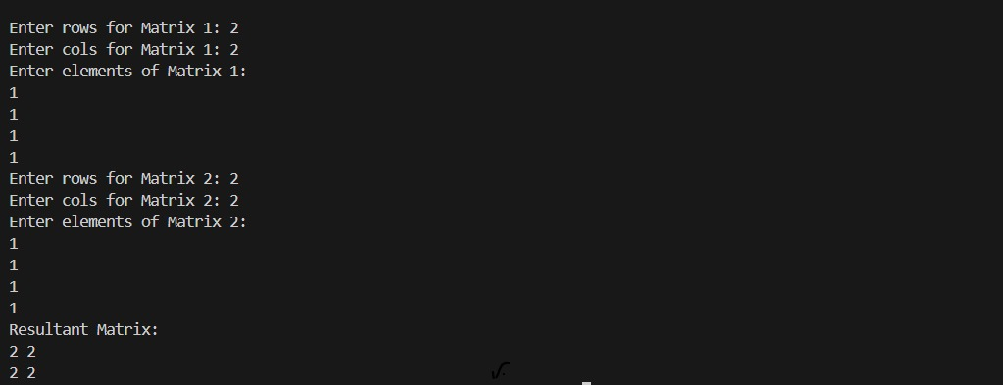

10. Write a program for to check whether a given String is Palindrome or not using recursion
Program :
string=input("Enter A Word:")
s=string[::-1]

if string == s:
print(f"{string} is A Palindrome")

else:
print(f"It is not A Palindrome ")

Output :
